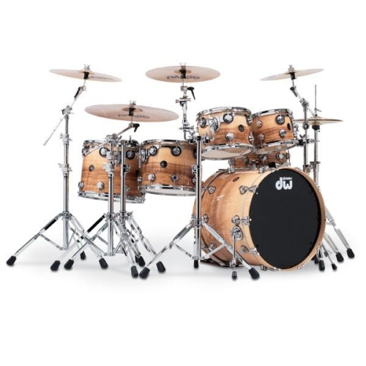k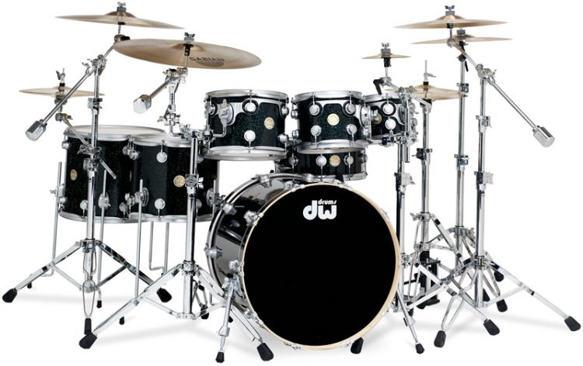
Phone: 201–704-7924

e-mail: artdonuts.epstein@gmail.com

website;

MICHAEL EPSTEIN
Michael Epstein
*
201-704-7924
*Beginners

*Intermediate

*Advanced

*All Ages

DRUM
LESSONS
Study drums with an accomplished musician with over 38 years of professional experience in both teaching and performing.
I Teach Beginners To Advanced Players Of Any Age
45 and 60 Minute Private Lessons In My Studio.
-45 minutes $50 60 minutes $60-
In Home Lessons Can Be Arranged
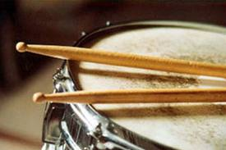

Drum Drome

Drum Lessons WithAn Experienced Teacher

Drum Drome

I am an empathetic supportive teacher, who creates a positive atmosphere in the practice room.
I help my students at all levels of ability and training to discover and expand their innate musical aptitude.
Lessons are designed to be fun. It’s about exploration, discovery, self expression and the pleasure of making music while you learn at your own pace.
Whether it’s rock, funk, jazz, fusion or metal, lessons are designed to fit your needs and interests.

You’ll learn what you want to play and at the same time you’ll learn what you have to know so that you continually progress and develop as a drummer and musician – right from the start.

Patient coaching and a thorough grounding in technique will help you translate your love of music into the ability to play the music you love.

We focus on laying a firm foundation in the areas of drum set technique.

You’ll learn the uses of matched versus traditional grip, stroke techniques, rudiments, sight reading, playing by ear, developing rock-solid time and learning graduated techniques for approaching and mastering four-way, hand and foot coordination and independence..

I emphasize a musical approach to playing on the drum set. We’ll focus on fills, snare technique, grooves, playing with a band and the art of listening.

Special emphasis is given to developing your own style in performance and improvisation.

Why Study With Me?

Drum Drome

e
Performing experience

I have worked with, among many others;

Freddie King, Gregg Allman, John Lennon, Long John Baldry, Patti Lupone, Manhattan Transfer, Diane Keaton, Richard Tee, Cornell Dupree, Alex Taylor and Chuck Berry in venues from Max’s Kansas City to Radio City to Madison Square Garden and more

I’ve played with innumerable R &B, Rock, Funk and Soul bands in NYC and New Jersey

I have extensive recording experience; Albums, Demos, jingles, Industrial shows and soundtrack recordings and Broadway Show cast albums

I have numerous Broadway and off-Broadway credits which include; Cats, A Chorus Line, The Wiz, and many more.

I’m offering 45 and 60 minute private lessons

ALL LESSONS take place in my private West Orange studio.

Drum Drome

I can arrange lessons in your home for an additional fee.
For rates and availability please contact me at
- 201-704-7924
- Website: drumdrome.yolasite.com

